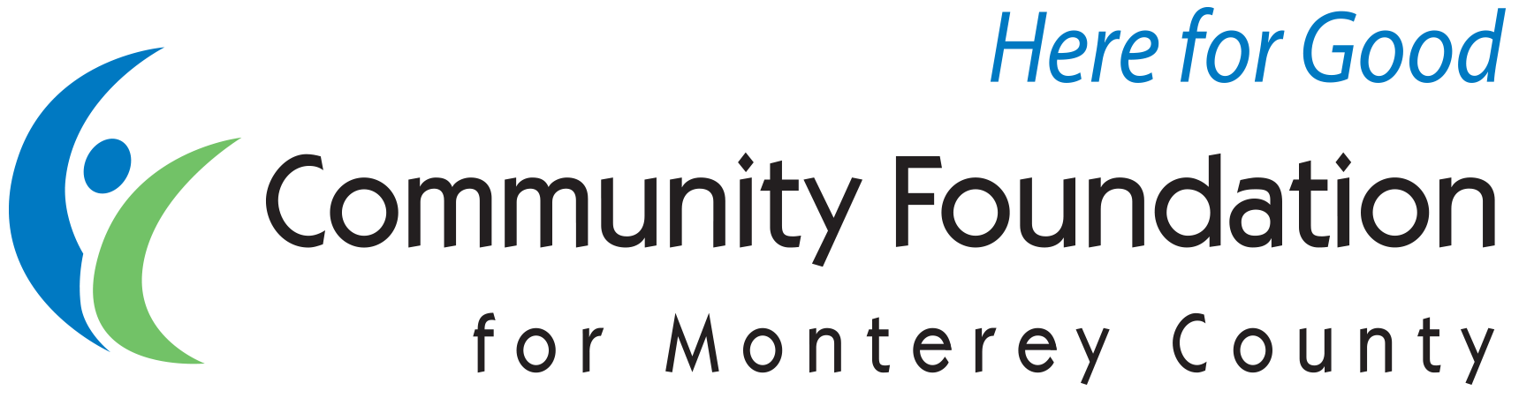

SAMPLE BEQUEST LANGUAGE

Basic information
Legal Name: Community Foundation for Monterey County
Address: 2354 Garden Road, Monterey, CA 93940
Phone: 831.375.9712
Tax ID: # 94-1615897
www.cfmco.org

The Community Foundation always encourages donors to discuss their estate plans with their professional advisor(s).

NATURE OF BEQUEST

Outright bequest in will

a. Specific dollar amount:
“I direct the sum of $_____ to the Community Foundation for Monterey County, 2354 Garden Road, Monterey CA 93940 to establish the (NAME) Fund to be perpetually recognized and administered by the Foundation in accordance with its guiding documents and its procedures for endowed funds.”

b. Share of, or entire residue, of estate:
“I direct (all or %) of the remainder of my property to the Community Foundation for Monterey County …

c. Specific property (personal property):
“I direct (description of property) to the Community Foundation for Monterey County…

d. Specific property (real estate):
“I direct all of my right, title and interest in and to the real estate located at (description of property) to the Community Foundation for Monterey County…

Outright bequest in trust

“Upon the death of the Settlor, the Trustee shall distribute (specific amount, percentage of estate, residue of estate) to the Community Foundation for Monterey County, 2354 Garden Road, Monterey CA 93940 to establish the (NAME) Fund to be perpetually recognized and administered by the Foundation in accordance with its guiding documents and its procedures for endowed funds.”

PURPOSE OF BEQUEST

Following the appropriate will or trust bequest language, include a statement about the purpose of the fund.

Unrestricted Fund of the Fund for Monterey County:*
“This Fund is unrestricted in purpose as part of the Fund for Monterey County.”

Field of Interest Fund of the Fund for Monterey County:*
(to fund agencies within a broad or specific area of interest, i.e. youth, arts, environment)
“This Fund is to be a Field of Interest Fund of the Fund for Monterey County and will support organizations and programs which (describe one or more areas of charitable interest).”

Designated Fund: (Created to benefit a specific agency/ies)
“This Fund is to be a Designated Fund, and grants from the Fund will exclusively support the following organizations: (list nonprofit organizations and/or programs and relative percentages if desired).”

Donor Advised Fund:
“This Fund is to be a Donor Advised Fund and (name, address) will be the Donor Advisor(s) during his or her lifetime to make grant recommendations to the Foundation's Board.”

Scholarship Fund:
“This Fund is to be a Scholarship Fund which will provide scholarship support to (choose the College Futures Monterey County Fund or describe scholarship purpose and selection criteria in detail).”

Bequest to an Existing Fund:
“This bequest is to be added to the (NAME) Fund, a component fund of the Community Foundation for Monterey County, and I direct that this bequest become part of this Fund.”

*Fund for Monterey County
The Fund for Monterey County is a permanent, endowed fund of the CFMC which is invested to grow and grant in perpetuity to respond to the changing needs of our community. Bequests creating Unrestricted and Field of Interest Funds become part of the Fund for Monterey County. For more information visit cfmco.org/FundforMontereyCounty.

NOTE: If the donor prefers, the CFMC can work with him or her to prepare a more detailed Fund Agreement or Letter of Intent which could then be referenced as follows in the will or trust: “...and administered by the Foundation in accordance with its guiding documents and its procedures for endowed funds and with the separate Fund Agreement or Letter of Intent previously executed with the Foundation on (date).”

For further information or questions please contact Christine Dawson, Senior Vice President of Philanthropic Services at christine@cfmco.org or Cecilia Romero, Director of Gift Planning at ceciliar@cfmco.org or call 831.375.9712.

