MC GIVES! COMMUNICATIONS SAMPLES 2021

- Before Mention campaign and “save the dates”

- Kick off Include MC Gives! message in existing channels (print, email, website, social media)

- During November 1 – December 31, 2021 (website live)
- Share Big Idea, use your specific link, utilize social capital, countdown to deadline
- Leverage Giving Tuesday 11/30/21 (2021 Giving Tuesday Toolkit - campaign tips)

- After Follow up/thank you’s/ share your results/impact

FACEBOOK

- Like partners and each other!
www.facebook.com/montereycountyweekly
www.facebook.com/cfmco
www.facebook.com/montereypeninsulafoundation

- Best practice: Reference partners with links if you are including them in your post:
@Montereycountyweekly @cfmco @montereypeninsulafoundation @MontereyCountyGives
- Share relevant posts from partners to amplify the campaign

- Sample Facebook Posts
- Customize link to your unique URL (once the MCGives website is live)
- Add photos (not just links)
- Add hashtag #MCGives

- We’re excited to participate in Monterey County Gives! to support _______________(YOUR BIG IDEA OR MISSION HERE). Donate now through 12/31 and your gift will go further through a % match! www.montereycountygives.com (YOUR CUSTOM URL) #mcgives @montereycountyweekly @cfmco @montereypeninsulafoundation

- XX days left to help your gift go further through Monterey County Gives! Donate now through December 31 at www.montereycountygives.com (YOUR CUSTOM URL) #mcgives @montereycountyweekly @cfmco @montereypeninsulafoundation

- Please donate by December 31 through Monterey County Gives! (YOUR CUSTOM URL) You can leverage your gift through a partial match and help (BIG IDEA). #mcgives @montereycountyweekly @cfmco @montereypeninsulafoundation

- Did you know if you are 72 or older, or (70 ½ if born before 7/1/49) you can give to your favorite organizations through an IRA #qualifiedcharitabledistribution to Monterey County Gives! Learn how it works at www.cfmco.org/IRA.
TWITTER
Follow & mention partners: @mcweekly @cfmco @attproam
Use custom link. Create shortlink if needed at www.bitly.com
- Leverage your year-end gift to (YOUR AGENCY NAME) through www.montereycountygives.com (or custom Gives! URL link) #MCGives

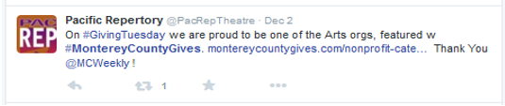
- Your gift to (YOUR AGENCY NAME) goes further through www.mcgives.com/ CUSTOM URL)

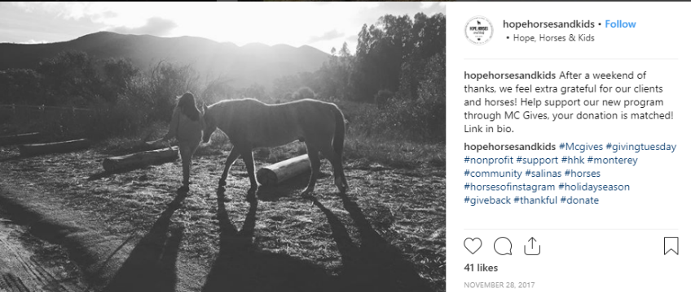
#INSTAGRAM
Use strong image and include relevant hashtags such as:
#mcgives #GivingTuesday #nonprofit #donate #thankful

NEWSLETTER/E-NEWS SAMPLE COPY
LEVERAGE YOUR YEAR-END DONATION THROUGH MONTEREY COUNTY GIVES!
November 11– December 31, 2010
(ORGANIZATION NAME) is delighted to be a participant in the 2021 Monterey County Gives! campaign. Your year-end gift goes further through the pro-rata match each gift receives. Your support can help make a difference to (BIG IDEA). This year’s program runs November 1 through midnight December 31, 2021. Donations may be made at www.montereycountygives.com in the (NAME YOUR CATEGORY I.E. ARTS & CULTURE) OR PROVIDE LINK TO CUSTOM URL). Since 2000, Monterey County Gives! has helped local nonprofit organizations raise over $35 million through the generosity of donors like you. Thank you for your support. Monterey County Gives! is a special project of the Monterey County Weekly, Community Foundation for Monterey County and Monterey Peninsula Foundation.
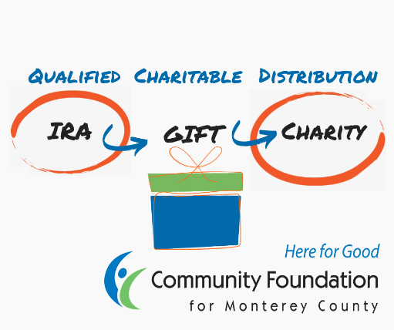

IRA Qualified Charitable Distribution (QCD)
Contributing from your IRA through Monterey County Gives! is an easy way to reduce your tax burden and make a gift to support the (NAME OF ORGANIZATION). If you are 72 or older, or (70 ½ if born before 7/1/49), you can make a gift from your IRA account up to $100,000 per year. The IRA QCD is a great way to make a meaningful gift. If you are married and file jointly, your spouse can also make a gift of up to $100,000 from his or her IRA. Contact the Community Foundation for Monterey County at 831.375.9712 for instructions or to learn more.

